Fluorescent Minerals
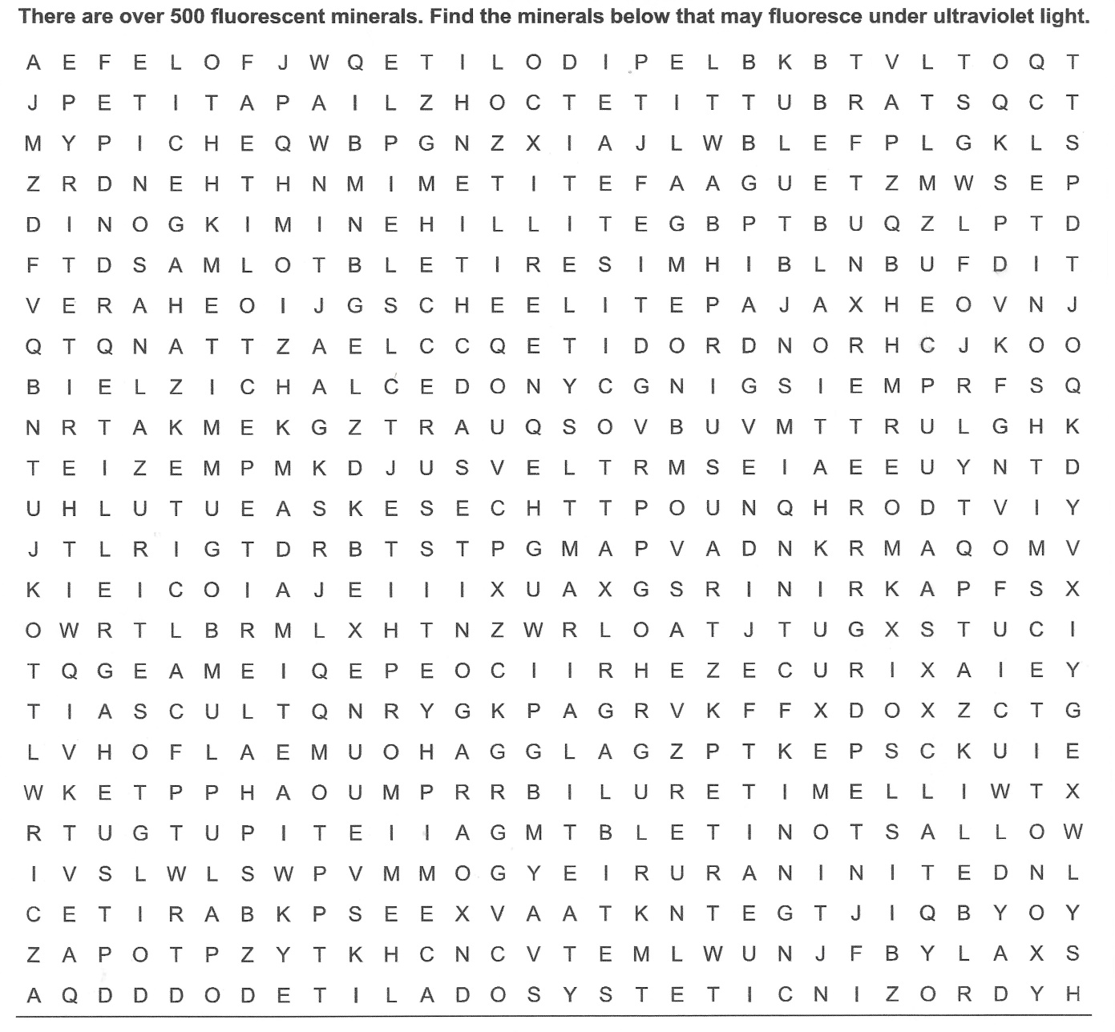
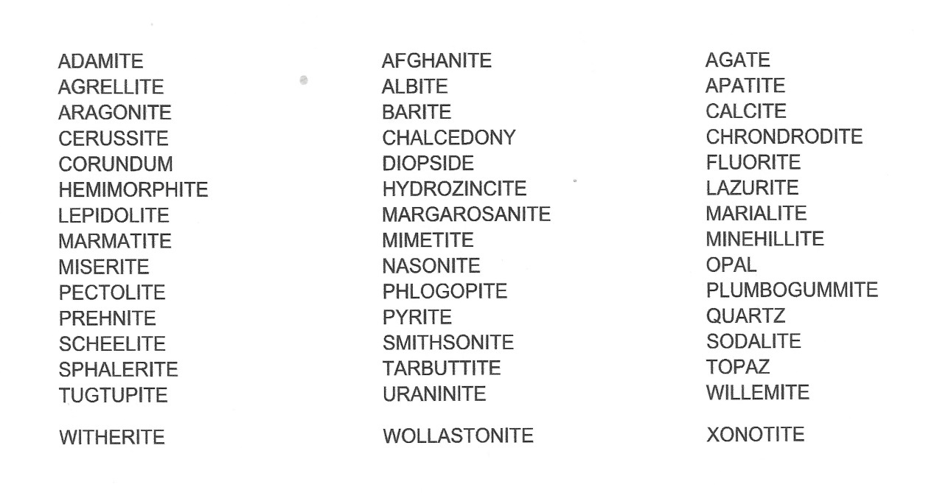
For More Information on Fluorescent Minerals, visit The Fluorescent Mineral Society website @ uvminerals.org

